UK Year 9 – Pre-test
15 Questions | 60 minutes | Calculator allowed
1. A microwave oven normally costs $160.
In a sale there is a discount of 15%.
Work out the sale price of the microwave oven.

$\$$______________________

2. Estimate $\frac{35.1-7.89}{2.55+6.3}$ by rounding each number to 1 significant number.

______________________

3. Two shapes A and B fit together to make a parallelogram.
Work out the sizes of the four angles in shape A.
Write them in the correct places on the diagram.
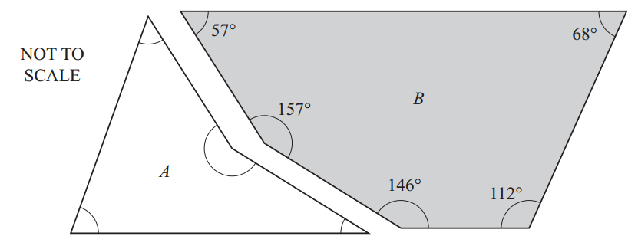
4. Ludwik is an engineer.
He charges a fixed call out fee plus an hourly rate for each job.
The table shows how much Ludwik charges for three jobs that last different amounts of time.
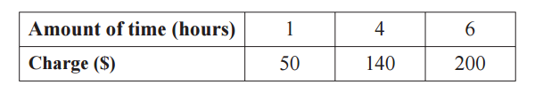
a) Draw the straight line graph that shows this information
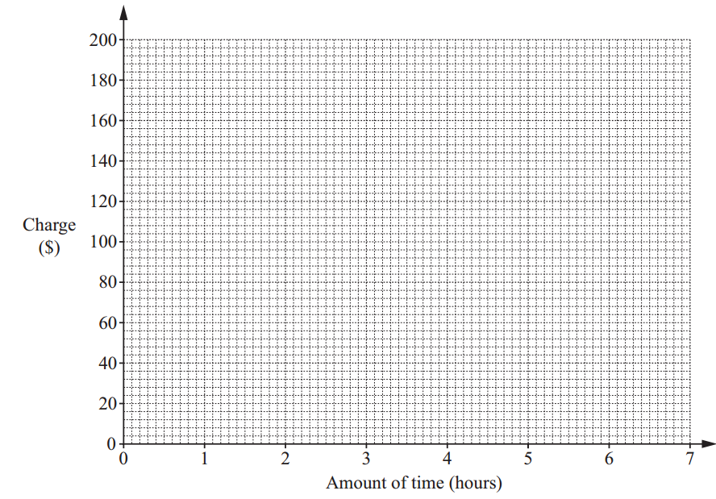
Write down Ludwik’s fixed call out fee.  This is the cost before he has worked any hours | $_______________
Work out Ludwik’s hourly rate. | $_______________

4. Draw lines to join each inequality to the correct solution set.
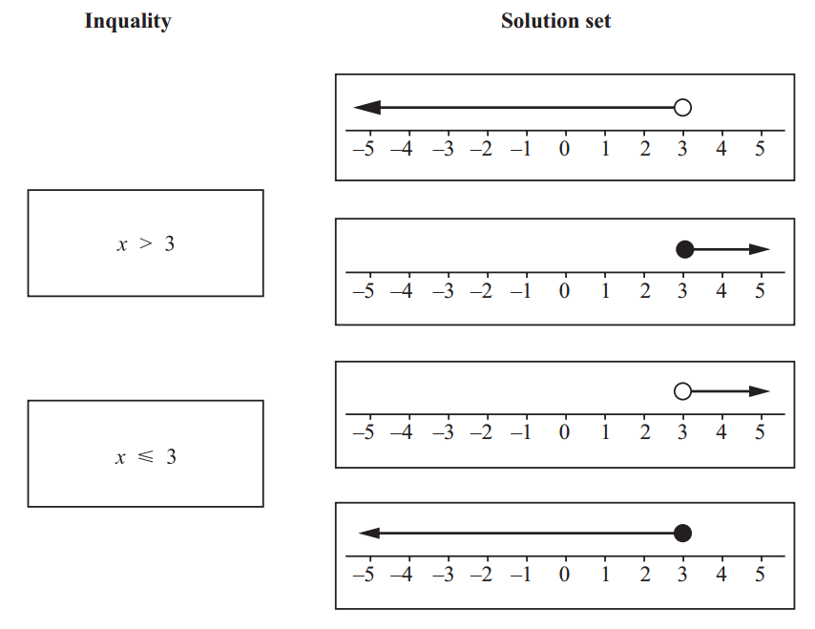
5. Here is quadrilateral P.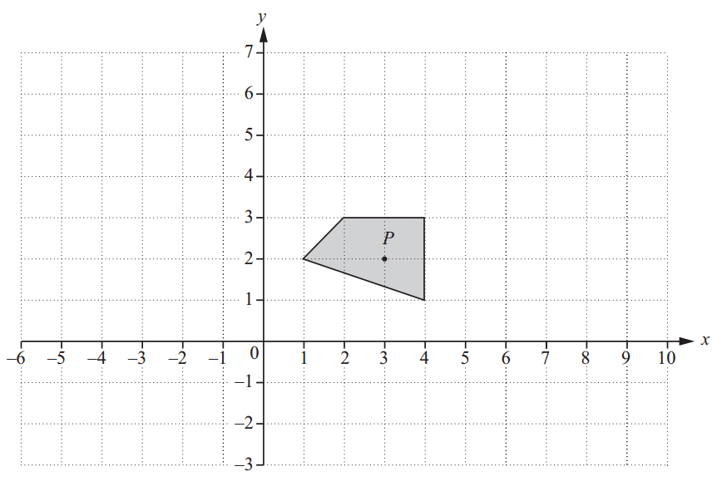
Draw an enlargement of quadrilateral P with scale factor 3 and centre of enlargement (3, 2).

6. Write as a single fraction.

$\frac{2}{x}+$$\frac{3}{x}$

__________________________________

7. Work out the value of $5x^{2}$ when $x=-3.4$

__________________________________
8. Here is a semi-circle with radius 5.5cm.
Work out the perimeter of this semi-circle.


_______________________________cm

9. The table shows some functions and their inverses.
Complete the table.
The first row has been done for you
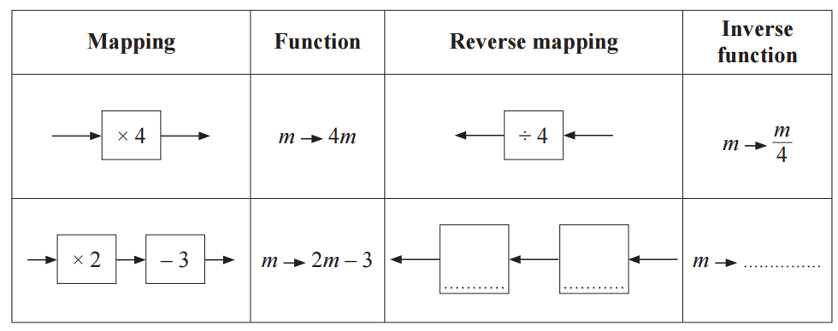

10. The table shows the population of Thailand for 1968 and 2013.
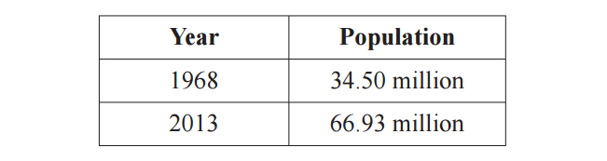
What is the percentage increase in the population of Thailand from 1968 to 2013?

_________________________________

11. Make x the subject of this formula.
$y=5(t+x)$

$x=$_________________________________
13. Put these numbers in order, from smallest to largest.
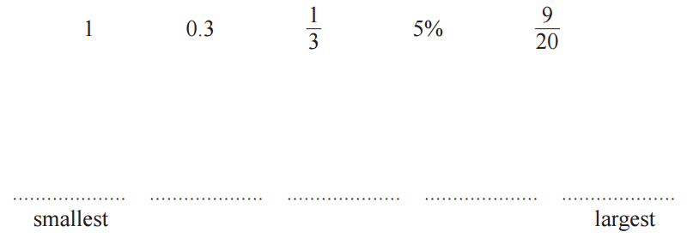

14. Mr Green spins two fair spinners.
Some of the possible outcomes are recorded in this table.
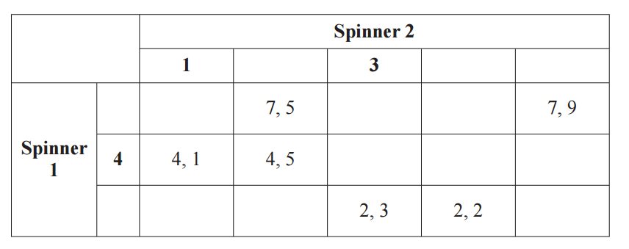
Complete the diagrams of the spinners by filling in the missing values.
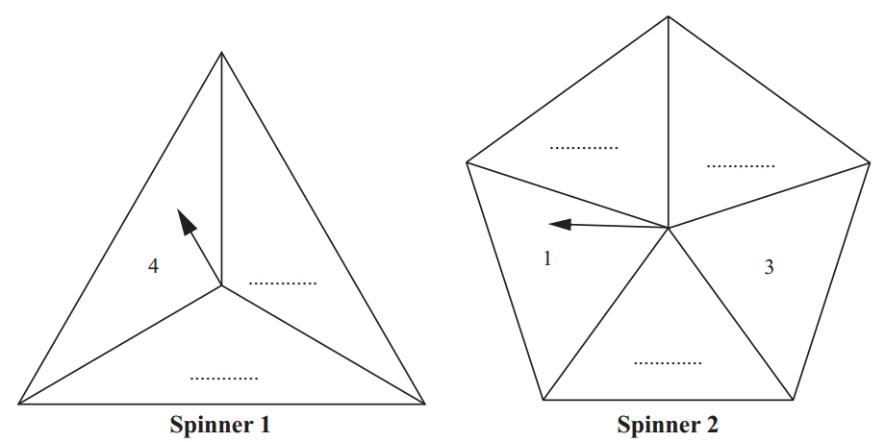

15. a) Complete this table of values for the equation 2y – x = 4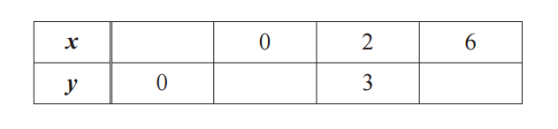
(b) Here is a graph of the line y + x = –1
Draw the graph of 2y – x = 4 on the same axes.
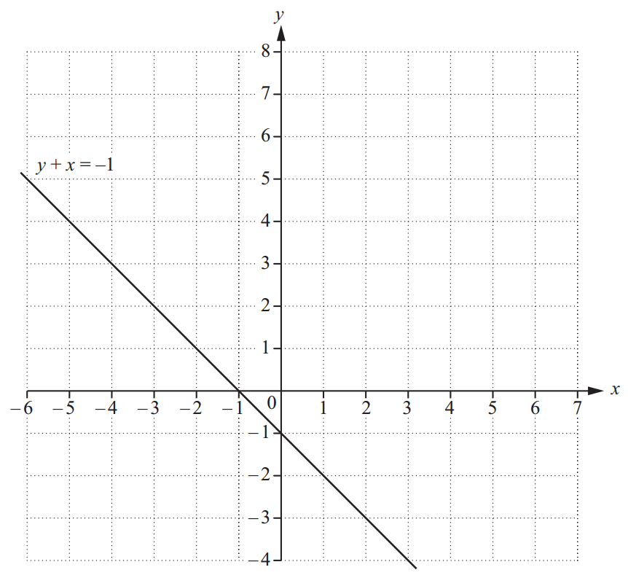
c) Use your graph to write down the solution to the simultaneous equations.

$x=$_________________________________
$y=$_________________________________

